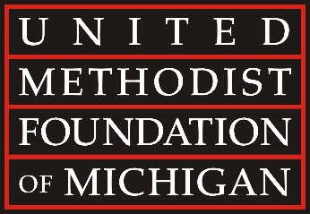

UMFMichigan.org ▪ 888-451-1929

March 1, 2024

Rev. Bartelmay has also been a key leader with the Foundation for several years. He has served as a diligent board director, chaired the Foundation’s Awards Committee, and been a member of the Executive Committee. When reflecting on the beginning of this new adventure, he enthusiastically shared, “I’m thrilled at becoming a part of the Foundation’s excellent team of leaders. I’m particularly looking forward to working with clergy and congregations helping to strengthen their financial capacity, as well as the vibrancy of their ministries.”

David S. Bell, President & Executive Director of the Foundation, shared his excitement about this new opportunity. “This new senior level position will once again grow our staff capacity to directly support pastors and church leaders. Brad will focus especially on those who are new to ministry or transitioning into new vocational or volunteer positions. Brad’s ability to patiently and confidently mentor pastors and church leaders is extraordinary. As a seasoned pastor, he has the unique combination of the empathy of a pastor’s heart and the tenacity of an entrepreneurial leader. I’ve witnessed firsthand his keen mind and collaborative efforts in overcoming challenging organizational constraints. We are very blessed to welcome Brad to our growing team. He is well-equipped to help congregations across all theological perspectives in the Wesleyan tradition.”

The United Methodist Foundation of Michigan has served churches, ministry leaders, and individuals since 1926. Staffed by dedicated professionals and governed by a volunteer Board of Directors, the Foundation offers a broad continuum of financial stewardship services, including value-aligned investment funds, stewardship consultation, planned giving seminars, grants, awards, and scholarships.

